Responsive Product Card Testing Note
Mobile – 390px:
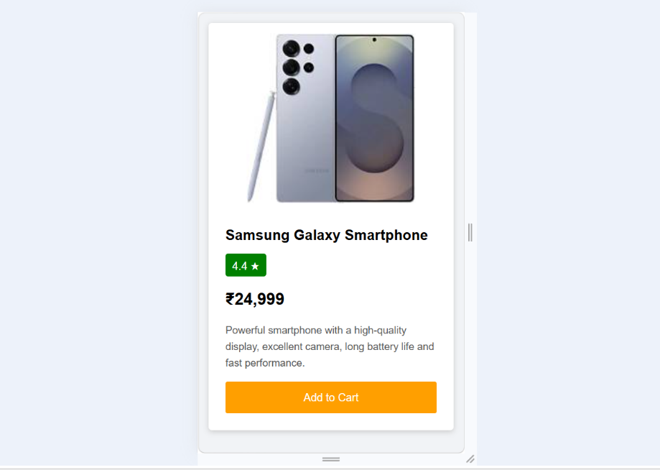
The product card changes from horizontal to vertical. The product image appears on top and the product details appear below. The font size and padding are reduced for better readability.
Tablet – 768px:
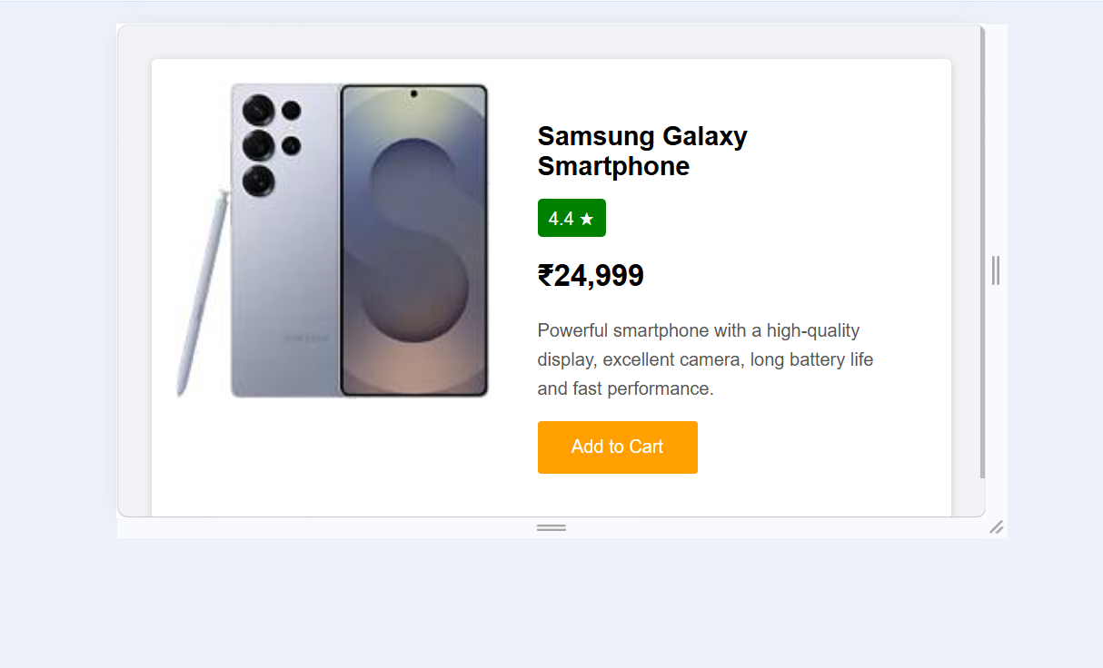
The product card remains horizontal. The image size, font size, gap, and padding are reduced compared with the desktop version.

Desktop – 1366px:
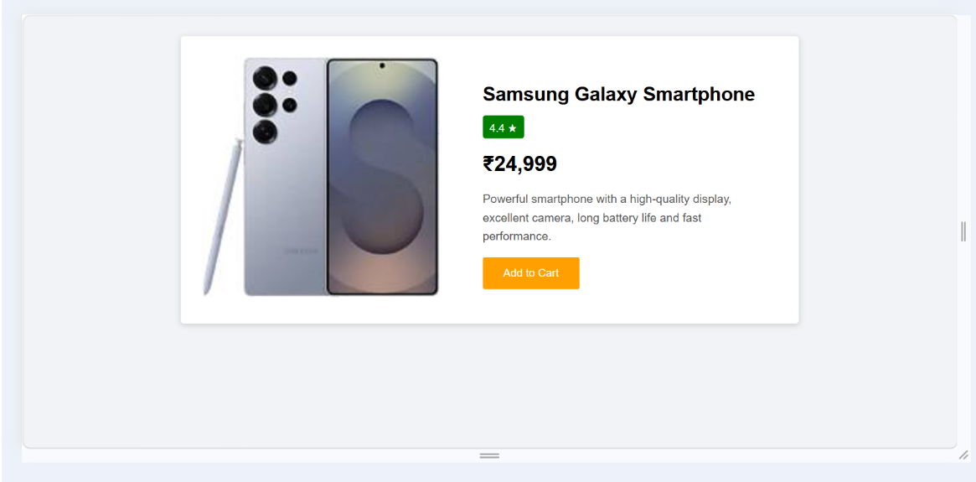
The product card uses the full horizontal layout with a larger image, larger fonts, and more padding for a comfortable desktop view.
Conclusion:
The product card is responsive and adjusts its layout, font size, image size, and spacing according to the screen width.

